Clermont County Dog Training Club
Sniff N’ Go
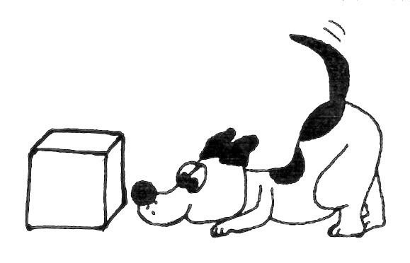
Sunday March 10, 2019
Registration from 10:00am – 2:00pm

6058 Kells Lane
Milford, OH 45150

Come out and practice interior searches
Five separate search areas
$5 per search

For further information contact Edith Markoff at clermontsec@gmail.com

